**Project Design Phase-II**

**Data Flow Diagram & User Stories**

|  |  |
| --- | --- |
| Date | 26 june 2025 |
| Team ID | LTVIP2025TMID34904 |
| Project Name | Smart Sorting: Transfer Learning for Identifying Rotten Fruits and Vegetables |
| Maximum Marks | 4 Marks |

**Data Flow Diagrams:**

A Data Flow Diagram (DFD) is a traditional visual representation of the information flows within a system. A neat and clear DFD can depict the right amount of the system requirement graphically. It shows how data enters and leaves the system, what changes the information, and where data is stored.

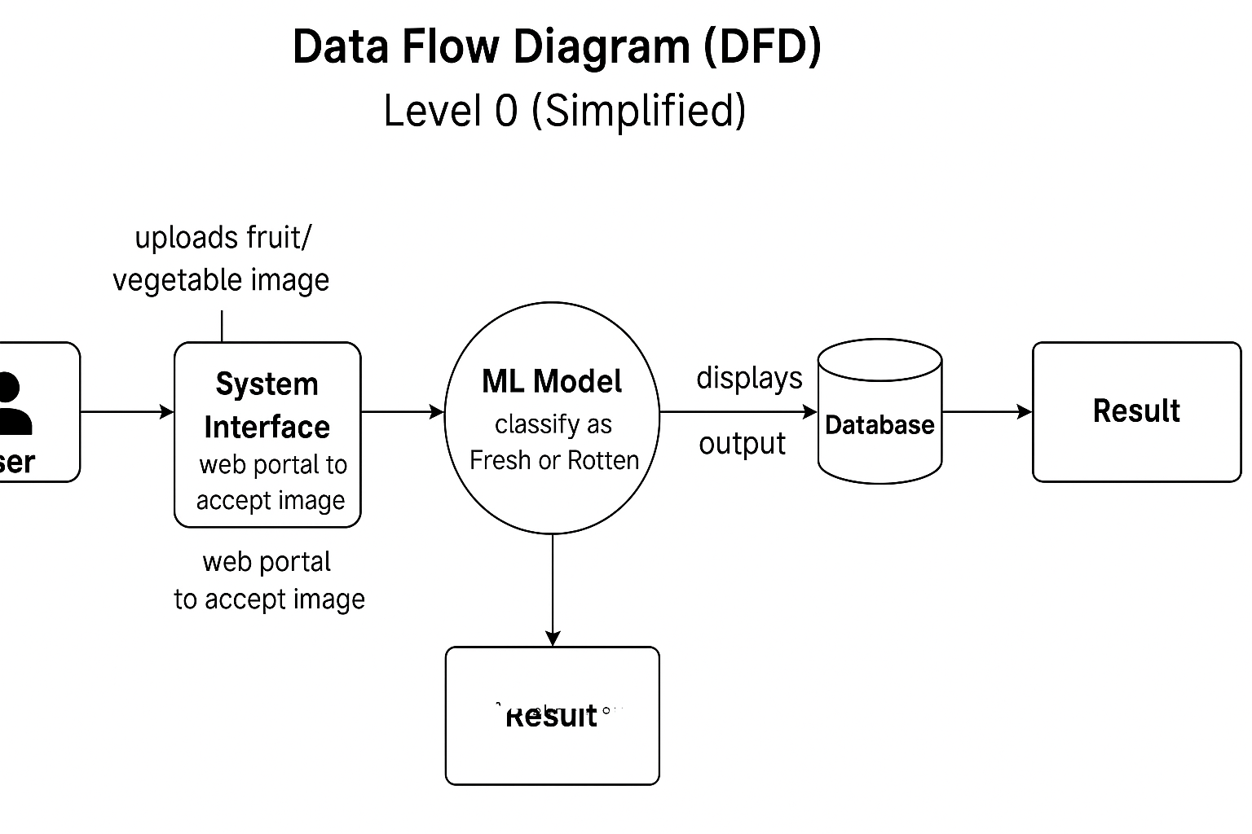

**User Stories**

| **User Type** | **Functional Requirement (Epic)** | **User Story Number** | **User Story / Task** | **Acceptance Criteria** | **Priority** | **Release** |
| --- | --- | --- | --- | --- | --- | --- |
| Customer (Web User) | Data Upload | USN-1 | As a user, I can upload an image of a fruit or vegetable to the system. | I can successfully upload an image. | High | Sprint-1 |
| Customer (Web User) | Prediction | USN-2 | As a user, I can view the classification result (Fresh or Rotten). | I can see the result after image upload. | High | Sprint-1 |
| Customer (Web User) | Image Storage | USN-3 | As a user, I can store and review my previously uploaded images and results. | I can view my upload history. | Medium | Sprint-2 |
| Customer (Web User) | Confirmation | USN-4 | As a user, I can receive confirmation when the image has been successfully processed. | I receive a success message. | Medium | Sprint-2 |
| Customer Care Executive | Data Review | USN-5 | As an executive, I can review user uploads and their classification results. | I can access a dashboard with user submissions. | Low | Sprint-3 |
| Administrator | System Monitoring | USN-6 | As an admin, I can monitor system performance and check classification logs. | I can access logs and monitor model activity. | Low | Sprint-4 |

**Summary of Sprints:**

* **Sprint 1:** Core Functions – Upload, Prediction
* **Sprint 2:** History, Confirmation Features
* **Sprint 3:** Customer Care Dashboard
* **Sprint 4:** Admin Monitoring Tools